《公版網站平台--利用[超級可編]做[列管文件]》
以管理員帳密登入後，開啟該頁的編輯頁面[超級可編]模組，點「編輯HTML語法」，如下圖：
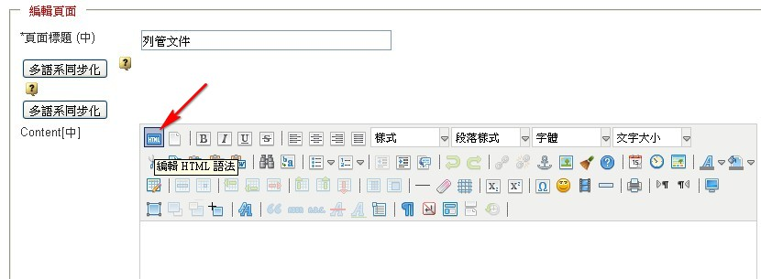
會跳出新視窗「HTML語法編輯器」，將以下語法(灰字部份)，Copy貼到該視窗後（請善用鍵盤ctrl鍵+c鍵，及ctrl+v鍵），再按下[更新]按鈕。

<p align="center"><strong>單位列管文件總覽表</strong></p>
<p align="left"> 單位名稱：稽核室</p>
<p align="right">文件管理者：賴秀慈</p>
<table width="90%" border="1" align="center" cellspacing="1">
<tr>
<th>文件編號</th>
<th>文件名稱</th>
<th>修訂日期</th>
<th>業務承辦人</th>
<th>備註</th>
</tr>
<tr>
<td align="center">&nbsp;</td>
<td>&nbsp;</td>
<td align="center">&nbsp;</td>
<td align="center">&nbsp;</td>
<td>&nbsp;</td>
</tr>
<tr>
<td align="center">&nbsp;</td>
<td>&nbsp;</td>
<td align="center">&nbsp;</td>
<td align="center">&nbsp;</td>
<td>&nbsp;</td>
</tr>
<tr>
<td align="center">&nbsp;</td>
<td>&nbsp;</td>
<td align="center">&nbsp;</td>
<td align="center">&nbsp;</td>
<td>&nbsp;</td>
</tr>
<tr>
<td align="center">&nbsp;</td>
<td>&nbsp;</td>
<td align="center">&nbsp;</td>
<td align="center">&nbsp;</td>
<td>&nbsp;</td>
</tr>
<tr>
<td align="center">&nbsp;</td>
<td>&nbsp;</td>
<td align="center">&nbsp;</td>
<td align="center">&nbsp;</td>
<td>&nbsp;</td>
</tr>
<tr>
<td align="center">&nbsp;</td>
<td>&nbsp;</td>
<td align="center">&nbsp;</td>
<td align="center">&nbsp;</td>
<td>&nbsp;</td>
</tr>
<tr>
<td align="center">&nbsp;</td>
<td>&nbsp;</td>
<td align="center">&nbsp;</td>
<td align="center">&nbsp;</td>
<td>&nbsp;</td>
</tr>
<tr>
<td align="center">&nbsp;</td>
<td>&nbsp;</td>
<td align="center">&nbsp;</td>
<td align="center">&nbsp;</td>
<td>&nbsp;</td>
</tr>
<tr>
<td align="center">&nbsp;</td>
<td>&nbsp;</td>
<td align="center">&nbsp;</td>
<td align="center">&nbsp;</td>
<td>&nbsp;</td>
</tr>
<tr>
<td align="center">&nbsp;</td>
<td>&nbsp;</td>
<td align="center">&nbsp;</td>
<td align="center">&nbsp;</td>
<td>&nbsp;</td>
</tr>
<tr>
<td align="center">&nbsp;</td>
<td>&nbsp;</td>
<td align="center">&nbsp;</td>
<td align="center">&nbsp;</td>
<td>&nbsp;</td>
</tr>
<tr>
<td align="center">&nbsp;</td>
<td>&nbsp;</td>
<td align="center">&nbsp;</td>
<td align="center">&nbsp;</td>
<td>&nbsp;</td>
</tr>
<tr>
<td align="center">&nbsp;</td>
<td>&nbsp;</td>
<td align="center">&nbsp;</td>
<td align="center">&nbsp;</td>
<td>&nbsp;</td>
</tr>
<tr>
<td align="center">&nbsp;</td>
<td>&nbsp;</td>
<td align="center">&nbsp;</td>
<td align="center">&nbsp;</td>
<td>&nbsp;</td>
</tr>
</table>
<p align="right">FM-11800-047<br />
表單修訂日期：102.06.27<br />
保存期限：永久保存</p>

如下圖：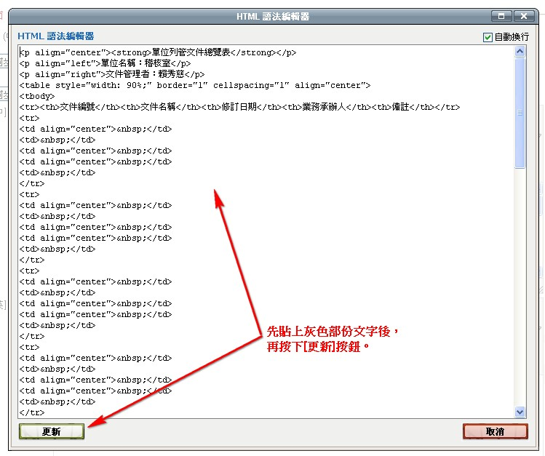

即在編輯框顯示[列管文件]格式及表格：
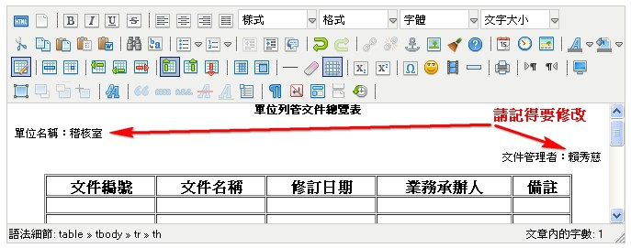

繼續輸入文件編號、文件名稱、修訂日期…等欄位的資料後，選取[文件編號]欄位的編號號碼，使其反灰，再按[加入/編輯網址]之圖示，如下圖：
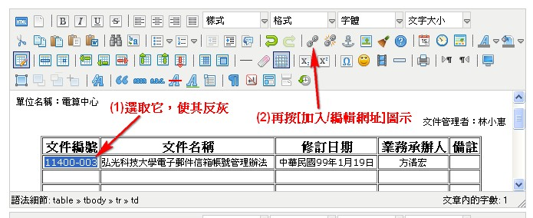
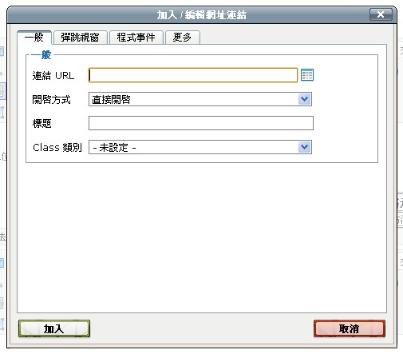

請另開一個IE視窗(或Google Chrome視窗)，登入帳密後，至原本上傳該文件的[檔案室]模組，找到相同的文件，於該文件上(鼠標呈現手形狀時)按滑鼠右鍵，選[複製捷徑]( IE)，或[複製連結網址](Google Chrome)，如下圖：
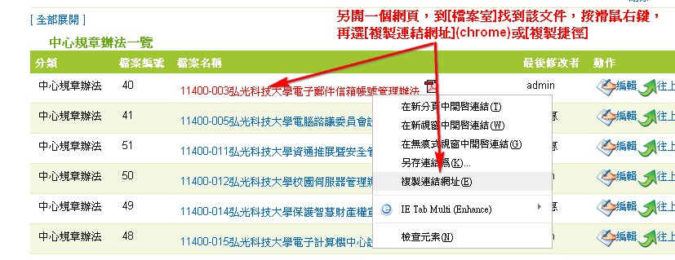

再回到原本的IE視窗(或Google Chrome視窗)，(1)於[連結URL]欄位，貼上，(2)[開啟方式]改選 開一個新視窗(_blank)，(3)再按[加入]按鈕
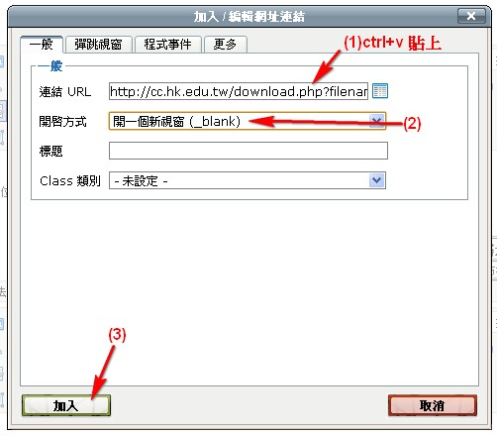
編輯完整個文件後，再按下[送出]，即完成。
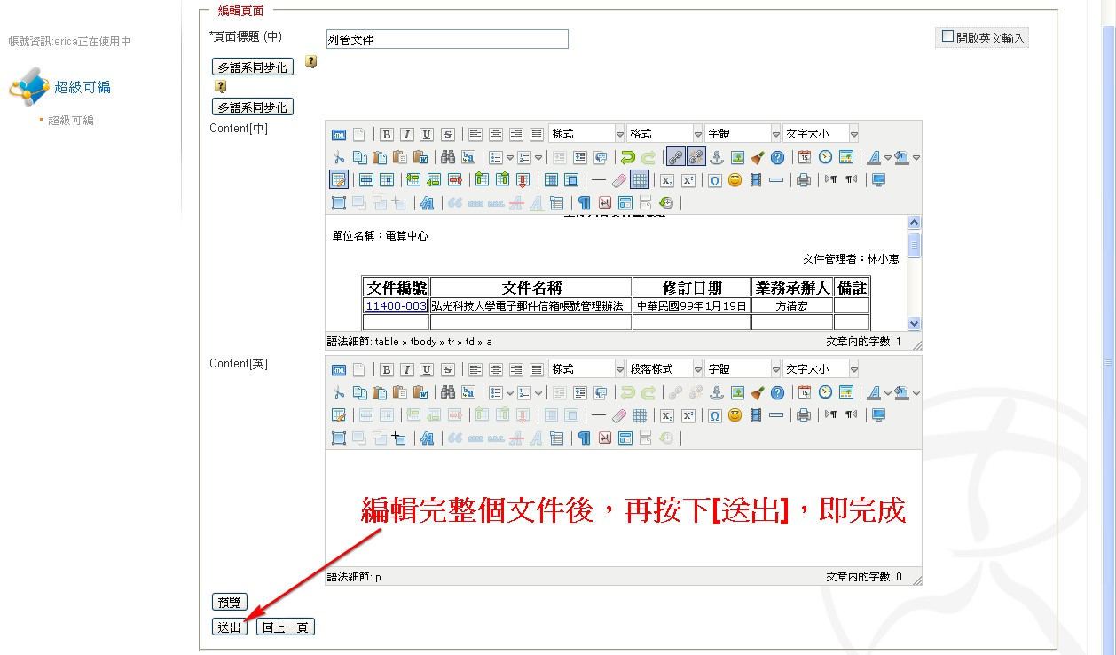

《公版網站平台--利用[超級可編]做[表單/紀錄總覽表]》
步驟同上，僅在「HTML語法編輯器」時，需要copy貼到該視窗的語法不同，請改貼以下文字：

<p align="center"><strong>表單/紀錄總覽表</strong></p>
<p align="left"> 單位名稱：稽核室</p>
<table width="90%" border="1" align="center" cellspacing="1">
<tr>
<th>表單編號</th>
<th>表單/紀錄名稱</th>
<th>最新制/修訂日期</th>
<th>保存期限</th>
<th>備註</th>
</tr>
<tr>
<td align="center">&nbsp;</td>
<td>&nbsp;</td>
<td align="center">&nbsp;</td>
<td align="center">&nbsp;</td>
<td>&nbsp;</td>
</tr>
<tr>
<td align="center">&nbsp;</td>
<td>&nbsp;</td>
<td align="center">&nbsp;</td>
<td align="center">&nbsp;</td>
<td>&nbsp;</td>
</tr>
<tr>
<td align="center">&nbsp;</td>
<td>&nbsp;</td>
<td align="center">&nbsp;</td>
<td align="center">&nbsp;</td>
<td>&nbsp;</td>
</tr>
<tr>
<td align="center">&nbsp;</td>
<td>&nbsp;</td>
<td align="center">&nbsp;</td>
<td align="center">&nbsp;</td>
<td>&nbsp;</td>
</tr>
<tr>
<td align="center">&nbsp;</td>
<td>&nbsp;</td>
<td align="center">&nbsp;</td>
<td align="center">&nbsp;</td>
<td>&nbsp;</td>
</tr>
<tr>
<td align="center">&nbsp;</td>
<td>&nbsp;</td>
<td align="center">&nbsp;</td>
<td align="center">&nbsp;</td>
<td>&nbsp;</td>
</tr>
<tr>
<td align="center">&nbsp;</td>
<td>&nbsp;</td>
<td align="center">&nbsp;</td>
<td align="center">&nbsp;</td>
<td>&nbsp;</td>
</tr>
<tr>
<td align="center">&nbsp;</td>
<td>&nbsp;</td>
<td align="center">&nbsp;</td>
<td align="center">&nbsp;</td>
<td>&nbsp;</td>
</tr>
<tr>
<td align="center">&nbsp;</td>
<td>&nbsp;</td>
<td align="center">&nbsp;</td>
<td align="center">&nbsp;</td>
<td>&nbsp;</td>
</tr>
<tr>
<td align="center">&nbsp;</td>
<td>&nbsp;</td>
<td align="center">&nbsp;</td>
<td align="center">&nbsp;</td>
<td>&nbsp;</td>
</tr>
<tr>
<td align="center">&nbsp;</td>
<td>&nbsp;</td>
<td align="center">&nbsp;</td>
<td align="center">&nbsp;</td>
<td>&nbsp;</td>
</tr>
<tr>
<td align="center">&nbsp;</td>
<td>&nbsp;</td>
<td align="center">&nbsp;</td>
<td align="center">&nbsp;</td>
<td>&nbsp;</td>
</tr>
<tr>
<td align="center">&nbsp;</td>
<td>&nbsp;</td>
<td align="center">&nbsp;</td>
<td align="center">&nbsp;</td>
<td>&nbsp;</td>
</tr>
<tr>
<td align="center">&nbsp;</td>
<td>&nbsp;</td>
<td align="center">&nbsp;</td>
<td align="center">&nbsp;</td>
<td>&nbsp;</td>
</tr>
</table>
<p align="right">FM-11800-016<br />
表單修訂日期：102.06.04<br />
保存期限：永久保存</p>

